Test plan for
Embelia: a smart health app

ChangeLog

Version | Change Date | By | Description
001 | 30.10.23 | Pratyush Pandey | Initial Draft

1 Introduction 2
1.1 Scope 2
1.1.1 In Scope 2
1.1.2 Out of Scope
1.2 Quality Objective 4
1.3 Roles and Responsibilities 4
2 Test Methodology 4
2.1 Overview 4
2.2 Test Level……………………………………………………………………………………………………………………………………..3
2.3 Test Completeness 7
3 Test Deliverables 7
4 Resource & Environment Needs 7
4.1 Testing Tools 13
4.2 Test Environment 13
5 Terms/Acronyms 14

Introduction
Mental health is an invaluable facet of overall well-being, and its significance is magnified in the context of college life, where students navigate academic challenges, social transitions, and newfound responsibilities. For Indian college students, this phase of life is often characterized by the pursuit of academic excellence and the forging of a path toward future ambitions. However, it is also a period marked by unique stressors and lifestyle choices that can significantly impact mental health outcomes.

This study delves into the intricate relationship between lifestyle choices and mental health among Indian college students, seeking to unravel the complexities of these connections. It is imperative to understand the factors that either bolster or undermine the mental well-being of this demographic, as it not only influences their academic success but also their quality of life beyond the classroom.

The importance of mental health is underscored by its global prevalence and the recognition that lifestyle choices are inextricably linked to its preservation. Healthy lifestyles, characterized by regular physical activity, balanced nutrition, adequate sleep, and effective stress management, have consistently been associated with reduced stress, improved mood, and enhanced overall well-being (Hassan, Gernigon, & Rabasa, 2017). Conversely, unhealthy choices, such as smoking, excessive alcohol consumption, and poor dietary habits, have been shown to increase the risk of developing mental health problems (Saini, Taggar, & Singh, 2016).

Scope

In Scope

Functional Requirement: -

1. Data Collection and Input:
- The system must collect and accept health-related data through a series of user-provided input, including age, height, weight, sleep duration, medical condition, occupation, and more.

2. Machine Learning Model Integration:
- The system shall incorporate a Random Forest Regressor machine learning model for health score calculation.

3. Custom Health Score:
- Users will receive a custom health score based on the input data, calculated by the integrated machine learning model.

4. Health Score Categorization:
- The app shall categorize users' health scores into different ranges: Excellent health condition (top 5%), Very good (55-85), Good (45-55), Satisfactory (35-45), Bad (0-35), based on Z score distribution.

5. Recommendation Feature:
- The app will provide health-related recommendations and activities based on the user's health score.

6. FAQ Section:
- The app includes a FAQ section that uses a machine learning model deployed on AWS to provide answers to user questions.

7. ChatGPT Integration:
- The app integrates ChatGPT for professional and user interactions.

Non-Functional Requirements: -

1. Performance:
- Speed: The system should efficiently process health data and provide health scores with minimal delay.
- Scalability: It should handle a scalable number of users and provide a responsive experience.

2. Quality:
- Health Score Accuracy: The calculated health scores should accurately reflect the user's health condition.
- Recommendation Accuracy: Recommendations and activities should be relevant to the user's health score.

Out of Scope

1. Advanced Health Analysis:
- Highly specialized health analysis, such as rare medical conditions or in-depth genetic analysis, is out of scope.

2. Specialized Hardware:
- Specific hardware requirements beyond standard web and mobile devices are not considered in scope.

3. Real-time Monitoring:
- Real-time monitoring of health metrics or instant health status updates is not part of this project.

4. Extensive Image Editing:
- Advanced image editing features and tools, beyond the app's core functionality, are considered out of scope.

5. Real-time Video Processing:
- Real-time video analysis or processing is not within the project's scope.

Quality Objective

- Ensure the Application Under Test conforms to functional and non-functional requirements
- Ensure the AUT meets the quality specifications defined by the client
- Bugs/issues are identified and fixed before go live
- Ensure that the style transfer process is optimized for efficiency and speed, allowing for rapid transformation of images while maintaining high-quality results.
- Prioritize a user-friendly and intuitive interface to enhance user experience, making it easy for users to upload images and customize style transfer.
- Ensure that the system functions correctly on a variety of devices, browsers, and operating systems to maximize user accessibility.

Roles and Responsibilities
Detail description of the Roles and responsibilities of different team members like
- QA Analyst- Pratyush Pandey
- Test Manager- Mr. Abhishek Goyal
- Configuration Manager- Prof. Akankskha
- Developers- Pratyush Pandey, Priyansh Singh, Sanjeevani Mangla
- Installation Team- Pratyush Pandey

Test Methodology

Overview

An Agile methodology is the most suitable for my project. It allows for flexibility, ongoing testing, and adaptation, which are essential for projects that involve machine learning, image processing, and AI. Agile enables you to respond to changing requirements and refine the style transfer algorithm as you gain insights from testing and user feedback.

Test Levels

The testing to be performed is white box testing.
The testing is performed by the developer’s team along with QA and Configuration Manager.

Unit Testing

1. Scope:
Individual components and functions of the app, including the ML model, health score calculation, recommendation engine, FAQ model, and ChatGPT integration.

2. Objective
To verify that each component works as intended and that individual functions, such as data collection, ML model predictions, and user interactions, produce the expected results.
3. Testing Approach:
Developers and machine learning engineers conduct unit tests for specific components and functions, ensuring that each unit performs its designated tasks accurately.

Integration Testing

1. Scope
- The interactions and interfaces between different modules of the app, including the connections between the user interface, ML model, recommendation engine, FAQ section, and ChatGPT integration.

2. Objective
- To ensure that the integration of various components does not introduce errors, bottlenecks, or inconsistencies in the app's functionality.

3. Testing Approach
- Developers and testers assess how data flows between components and detect any integration issues that might affect the overall functionality.

Functional Testing

1. Scope
- The complete Smart Health App, covering the entire user journey from data input to health score calculation, categorization, recommendation, FAQ section, and professional chat interactions.

2. Objective
- To validate that the app functions according to specified requirements and that it performs accurate health score calculations and provides relevant recommendations.

3. Testing Approach
- Testers execute functional tests by providing sample health-related data and assessing that the app delivers the correct health scores and recommendations based on the input.

Performance Testing

1. Scope
- Assessing the app's speed and efficiency in handling user interactions, data processing, and delivering health scores and recommendations.

2. Objective
- To measure the app's response time, resource utilization, and how well it performs under various user loads and conditions.

3. Testing Approach
- Performance tests evaluate the app's responsiveness and resource usage to ensure it can handle multiple concurrent users without significant performance degradation.

Usability Testing

1. Scope
- The user interface and overall user experience, including the ease of inputting health-related data, understanding health scores, and navigating the app.

2. Objective
- To assess the user-friendliness and intuitiveness of the interface to ensure users can easily interact with the app.

3. Testing Approach
- Usability tests involve real users interacting with the app to evaluate its ease of use, clarity, and overall user experience.

Security Testing

1. Scope
- The app's security mechanisms, especially for handling sensitive health-related data and user interactions.

2. Objective
- To identify and mitigate potential security vulnerabilities, including data breaches, unauthorized access, and data encryption.

3. Testing Approach
- Security testing includes penetration testing, encryption checks, and access control assessments to ensure user data is protected.

Compatibility Testing

1. Scope
- The app's compatibility with various platforms and devices, including different browsers, operating systems, and mobile devices.

2. Objective
- To ensure that the app functions correctly and displays properly on a wide range of user devices.

3. Testing Approach
- Testers verify that the app is compatible with various devices and configurations to provide a seamless experience for all users.

Regression Testing

1. Scope
- The entire app after updates or changes, including new features or modifications to existing functionality.

2. Objective
- To confirm that new changes or enhancements do not introduce defects or negatively impact the app's existing functionality.

3. Testing Approach
- Automated regression tests are executed to validate that previously tested features still work as expected after any updates or changes to the app.

Test Completeness
Here you define the criterias that will deem your testing complete.
For instance, a few criteria to check Test Completeness would be
- 100% test coverage
- All Manual & Automated Test cases executed
- All open bugs are fixed or will be fixed in next release
- All content and style transfer tests have been executed, ensuring that various input images have been processed successfully and meet the defined content and style transfer criteria.
- Automated regression tests have been executed, and previously tested features still work as expected after updates or changes.

Test Deliverables

Test cases: -

Test Case | Test Objective | Test Data | Expected Result |  | Actual Result | Pass/Fail
1 | User Login | User Id and Password | Only Valid User login in the system |  | Valid Login Successful | Pass
2 | User Login | User Id and Wrong Password | Login Fails for wrong credentials |  | Login Fails for wrong credentials | Pass
3 | User Login | Wrong User Id and Password | Login Fails for wrong credentials |  | Login Fails for wrong credentials | Pass
4 | User Login | Wrong User Id and Wrong Password | Login Fails for wrong credentials |  | Login Fails for wrong credentials | Pass
4 | Model Training | Training Model with Survey Dataset | Model successfully trained |  | Model successfully trained | Pass
5 | Health Score Predictor | Finding the score for user Data | User Health Score Prediction |  | User Health Score Prediction | Pass
6 | Chat AI Integration | Give answer for User Question | AI Generated Answer Predictions |  | AI Generated Answer Predictions | Pass
7 | FAQ Integration | Give answer for general Question ML Based | ML Based Answer for User Question  Received |  | ML Based Answer for User Question  Received | Pass
8 | Mutation Testing | Changed Loops and Condition | Does not reflect same result |  | Did not reflect same result | Pass

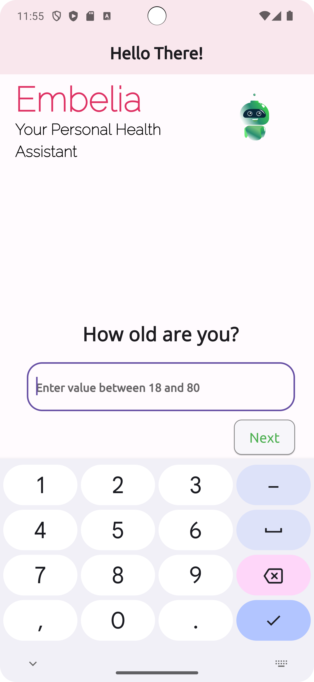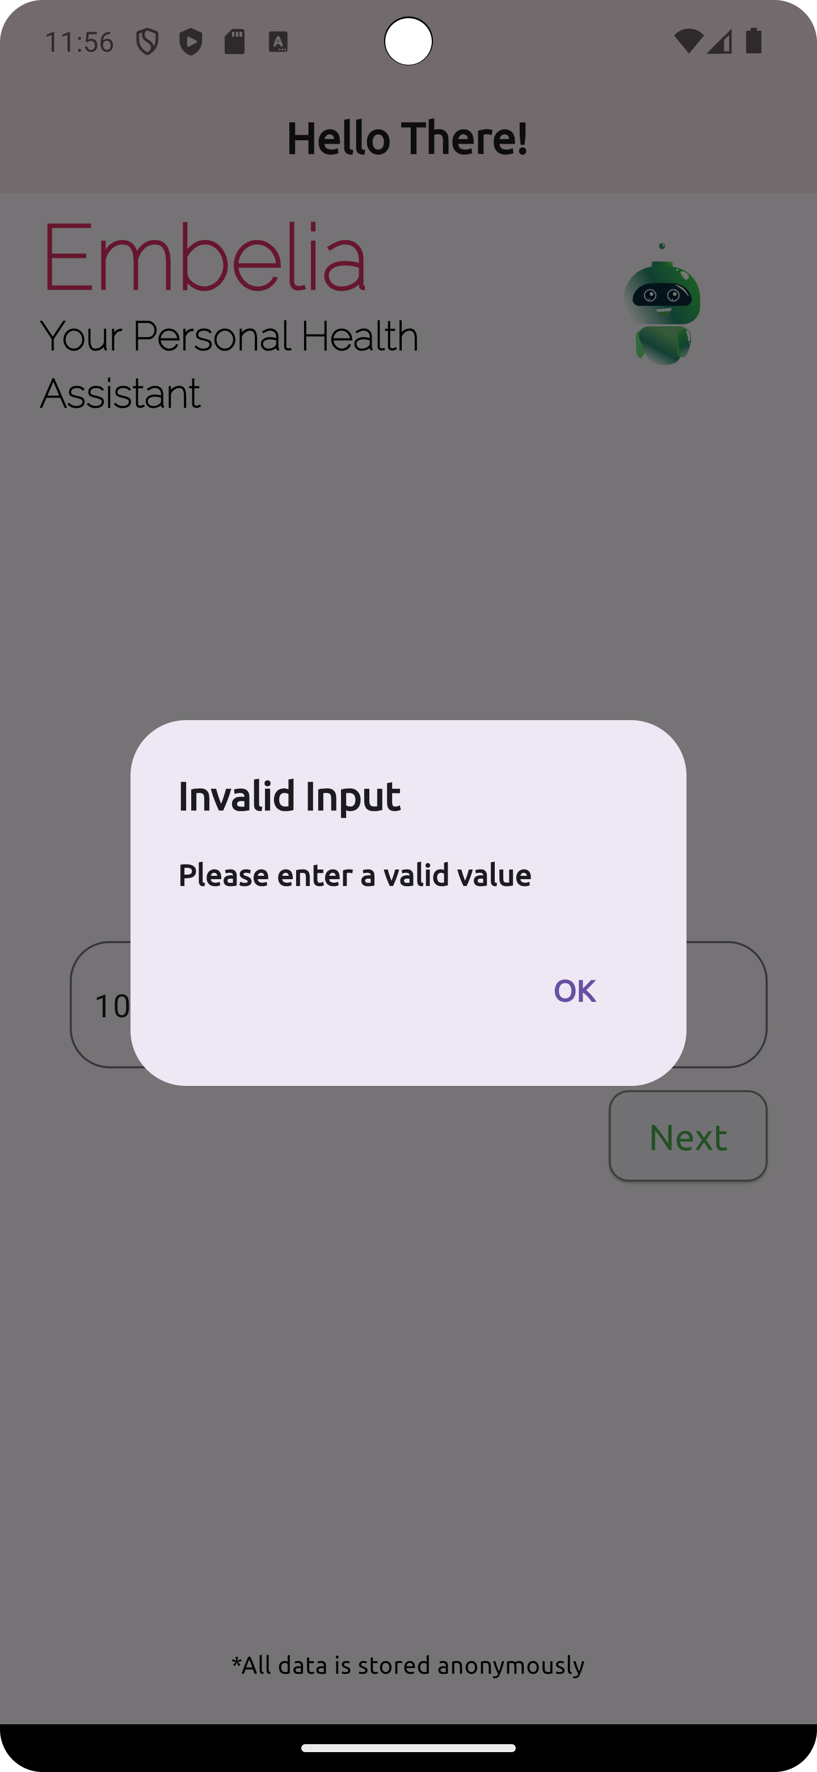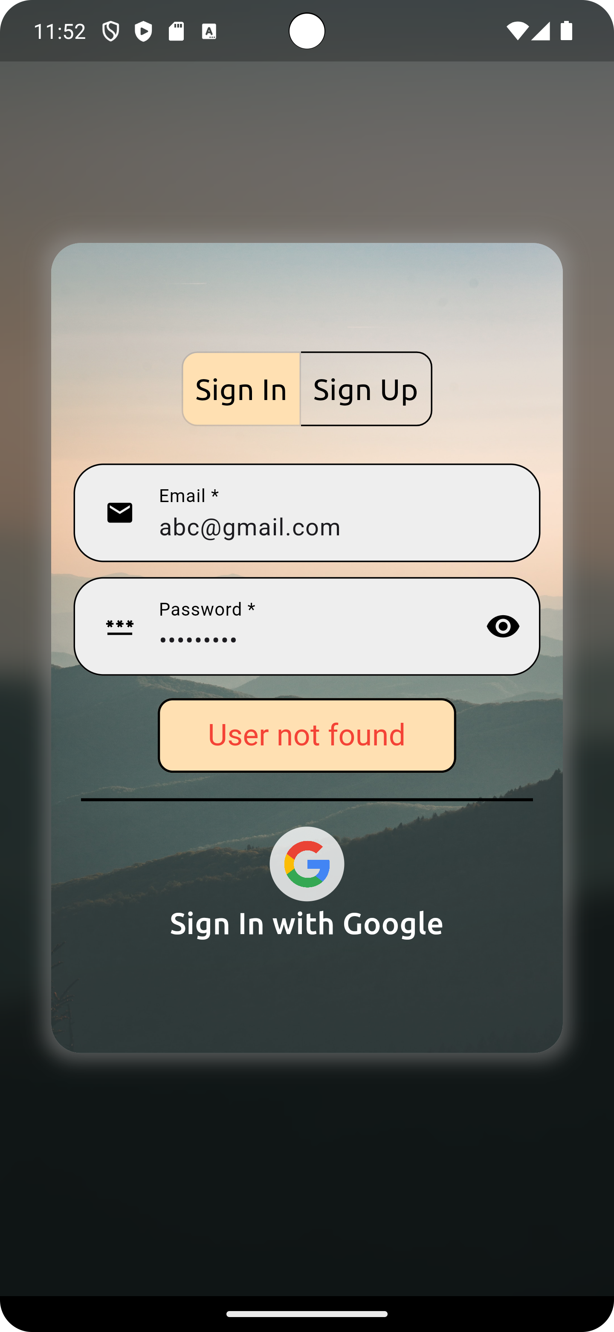

Decision Table for User Login

Conditions | Rule 1 | Rule 2 | Rule 3 | Rule 4
Username | False | True | False | True
Password | False | False | True | True
Output(e/h) | error | error | error | homepage

Test case Output Images

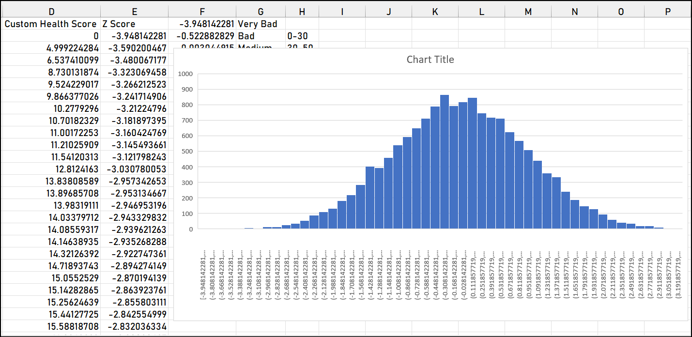

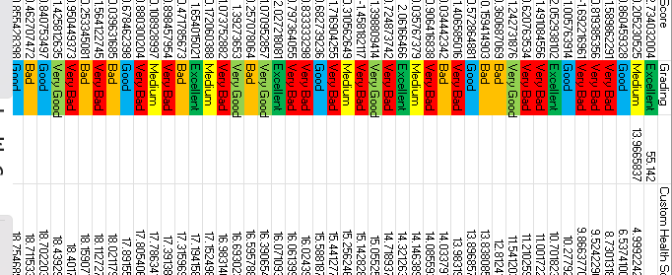

Resource & Environment Needs

Testing Tools

1. Requirements Tracking Tool:
JIRA: JIRA is a versatile tool for tracking requirements, user stories, and project tasks. It can help manage and prioritize project requirements effectively.

2. Bug Tracking Tool:
Bugzilla: Bugzilla is an open-source bug tracking tool that allows teams to efficiently track and manage software defects and issues.

3. Automation Tools:
TensorFlow: TensorFlow provides a framework for automated testing of machine learning models, including those used in neural style transfer. It can be used for automating model testing and validation.

Test Environment
It mentions the minimum hardware requirements that will be used to test the Application.

Following software’s are required in addition to client-specific software.

- Windows 8 and above
- Office 2013 and above
- MS Exchange, etc.

Terms/Acronyms
Make a mention of any terms or acronyms used in the project

TERM/ACRONYM | DEFINITION
API | Application Program Interface
AUT | Application Under Test

Project Guide: Mr. Abhishek Goyal Project Coordinator: Mrs. Neha Shukla

Signature: Signature:

Project Mentor: Mr. Anurag Mishra

Signature:

